a

Q: Are there any side effects?

A: No. A small percentage of patients report slight flushing or congestion for a short time (an hour or so) after their session, but this is actually a sign that the body is detoxifying (a good thing)! This process is safe, fast, non-invasive and painless. Unlike skin tests the actual substance is not used, so the body perceives its presence, it as if it were there, but does not act upon it.

Q: Does insurance cover assessment and therapy?

A: At this time, therapy and assessment are provided on a cash basis and are not yet covered by insurance. However, if your insurance offers a Flexible Spending Account (FSA) you may be able to apply the services toward that account.

Q: Why should I pay for this service:

A:Compared to managing your symptoms, and the fact that most other treatments prove unsuccessful, this is a relatively inexpensive, alternative, effective option, that can relieve a lifetime of suffering, in a short period of time. Our goal is to make you well and we will provide care until we clear your symptoms

Q: What does a typical full course of therapy cost?

A: We can tell you is that we have several hundred doctors across the country that utilize the BioScanSRT within their practice and that charges will vary from clinic to clinic. Other treatment is necessary for an extended period of time, only manages symptoms, and costs significantly more.

Q: How can Stress Reduction Therapy help everyone?

A: Because EVERYONE has stress!

**BioScanSRT: The Future of Wellness.**

**BioScanSRT**

**Stress Reduction Therapy**

**Our Goal Is To Help You Stay Well**

**And Make It Unnecessary**

**For your Body To Become Sick**

Questions

&

Answers

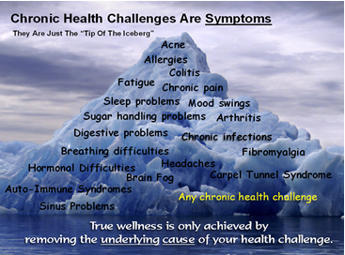

SRT is a remarkable new procedure that combines the disciplines of Acupuncture, Biofeedback and Homeopathy with laser technology.

A computerized scan or test is done to see what your body is sensitive to, and how it is out of balance, then help it learn not to be.

**EPTER CHIROPRACTIC**

**Jack L. Epter D.C., F.I.A.M.A.**

100 West Indiantown Road

Jupiter Florida 33458

561 575-4400

Visit us at:

[www.epterchiropractic.com](http://www.epterchiropractic.com)

To Learn More About BioEnergetic Medicine

It’s Your Body,Your Health, Your Choice









We recommend a system checkup every three months for wellness maintenance after you complete your recommended protocol.

Q: How many visits are needed?

A: The number of visits required depends on the patient, the extent or severity of their conditions, and their state of overall health and well being. The BioScanSRT Basic Protocol is comprised of two (2) primary procedures. The first visit consists of the 100-point Wellness Inspection. This will determine how many visits are necessary. Most patients require on average between 5-7 visits. Some patients/clients require advanced protocols as well.

Q: How long is a typical appointment?

A: The 100-point Wellness Inspection takes between 10-12 minutes. Nano SRT Processing Sessions take approximately 10-15 minutes each.

Q: When do patients notice improvement?

A: Individual timetables to achieve symptomatic relief will vary based on the individual's severity of conditions and state of overall health. Many patients notice an increase in their quality of health after the first or second visit.

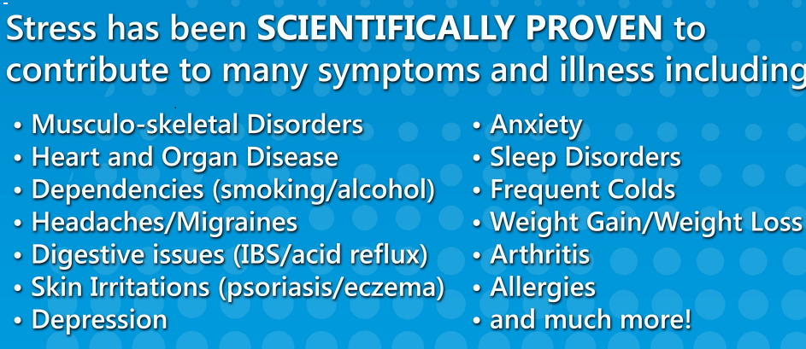

#### Q: What substances can the BioScanSRT identify as stressors?

#### A: The BioScanSRT contains tens of thousands of substances in the main procedure libraries and up to an additional 50,000 substances in the advanced procedure libraries. This technology can identify almost every known substance that could possibly cause a stress reaction. The BioScanSRT contains the most comprehensive substance library of any devices of this type.

#### Q: What does the BioScanSRT treat?

#### A: The BioScanSRT Wellness System does not diagnose or treat any specific condition. Through the use of our FDA-cleared biofeedback technology, the BioScanSRT is able to assess with a very high degree of specificity which substances create increased levels of stress to the body.

#### These specific stress inducing substances are often times what trigger the nervous systems fight or flight reactions which are expressed in a myriad of symptoms that have been scientifically proven to be associated with high levels of stress. Our belief is that through the use of our state-of-the-art technology, the BioScanSRT can safely, effectively and quickly reduce stress which will therefore provide for improved health, and the absence of symptoms.

#### Q: How long with the results last after I complete treatment? A: Results to date are termed indefinite. Patients and Doctors report elimination of symptoms without recurrence in most cases.

#### Because allergies , sensitivities, and other health issues can develop in adulthood, elimination or alleviation of a symptom does not mean other symptoms may not present over time.

Q: What does the BioScanSRT do:

A: Substance specific frequencies converted to a digital format, and presented in the form of sound and light, are what allow for patient assessment and therapy. The frequencies are what make it possible to assess thousands of substances and sensitivities, then allow the brain and nervous system to record a new association that is positive or neutral instead of the inappropriate ones causing symptoms, that were previously stored in memory. This breaks the link between the stimulus and response, makes symptoms unnecessary, creates balance and harmony, from dis-ease and disharmony, and allows the body to function better .

Q: What types of health care practitioners use the BioScanSRT?

A: Because the BioScanSRT is a non-invasive and painless therapy, it is used by Medical Doctors (MD), Doctors of Chiropractic (DC), Doctors of Osteopathy (DO), Homeopathic Doctors, Naturopathic Doctors, Acupuncturists and many others.

Q: Is the BioScanSRT Wellness System safe?

A: Yes. the BioScanSRT is safe and effective for people of all ages, and is even successfully used by veterinarians on animals.

The BioScanSRT emits energetic frequencies during an assessment that are essentially no different than sound waves which are no more harmful than frequencies generated by listening to the radio at home or in your car.