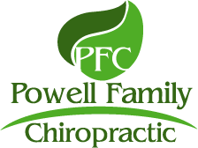
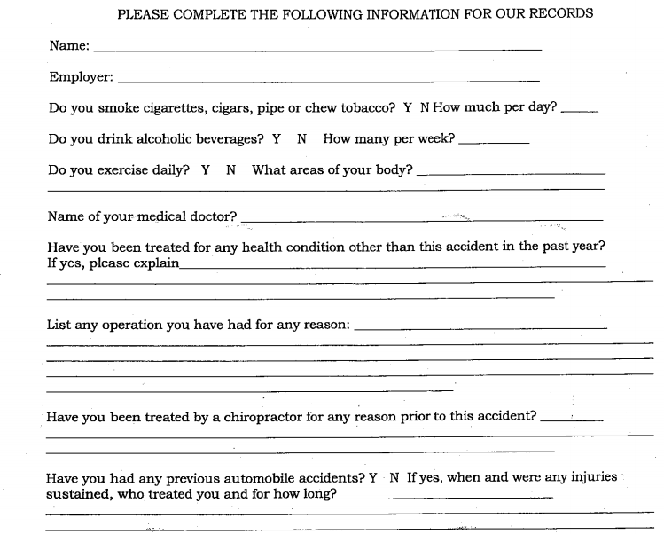
MACEO POWELL, D.C., C.P.E.
234 N. Rhodes Ave., Suite 105 ~ Sarasota, FL, 34232
Office 941-702-9944 ~ Fax 941-870-8948

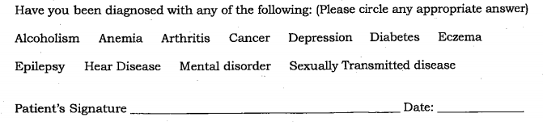
______________________________________________________________________________

AUTOMOBILE ACCIDENTAL INJURY FORM
PLEASE ANSWER ALL OF QUESTIONS
PLEASE PRINT CLEARLY ALL ANSWERS and SIGN EACH FORM AT THE BOTTOM

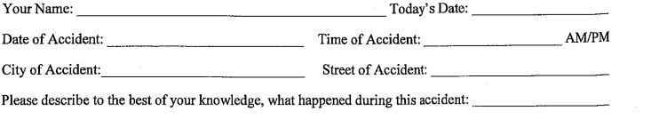
____________________________________________________________

____________________________________________________________

____________________________________________________________

____________________________________________________________
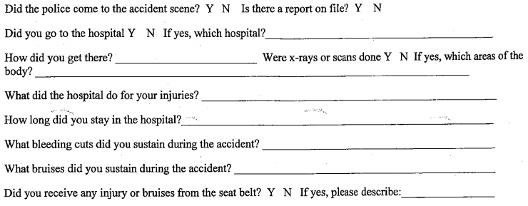
*******************************************************************

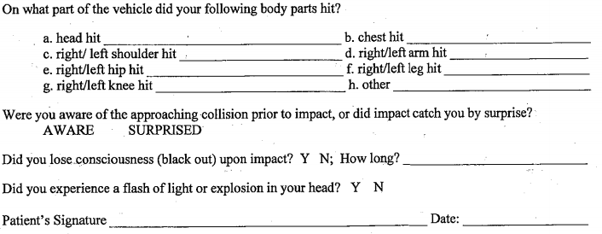
AUTOMOBILE ACCIDENTAL INJURY FORM
Please circle all symptoms you have noticed since the accident:
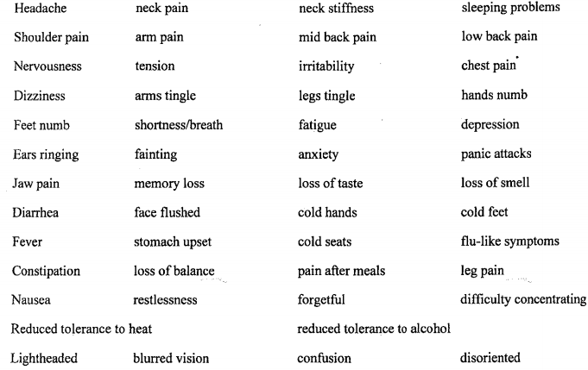

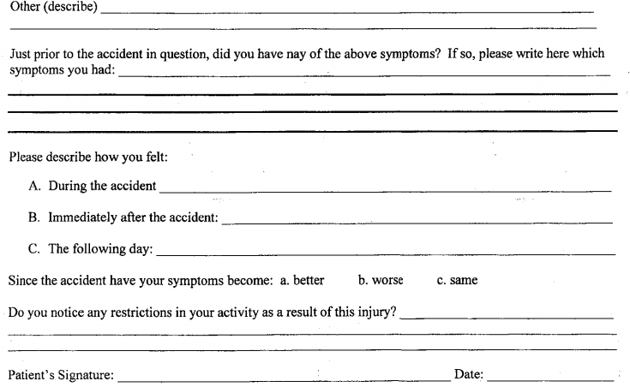

AUTOMOBILE ACCIDENTAL INJURY FORM

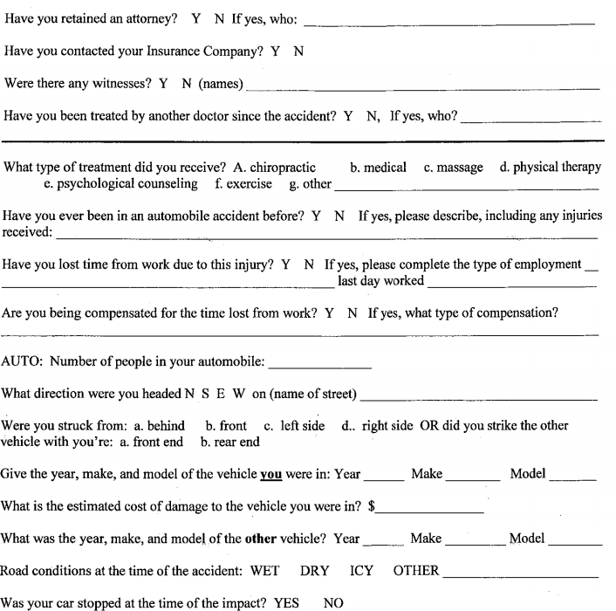

MACEO POWELL, D.C., C.P.E.
234 N. Rhodes Ave., Suite 105 ~ Sarasota, FL, 34232
Office 941-702-9944 ~ Fax 941-870-8948
AUTOMOBILE ACCIDENTAL INJURY FORM

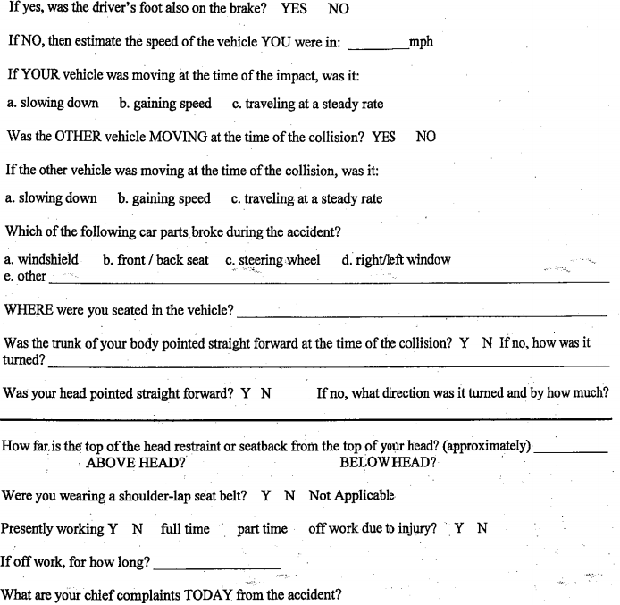

MACEO POWELL, D.C., C.P.E.
234 N. Rhodes Ave., Suite 105 ~ Sarasota, FL, 34232
Office 941-702-9944 ~ Fax 941-870-8948

