MACEO POWELL, D.C., C.P.E.
PEDIATRIC INTAKE & HISTORY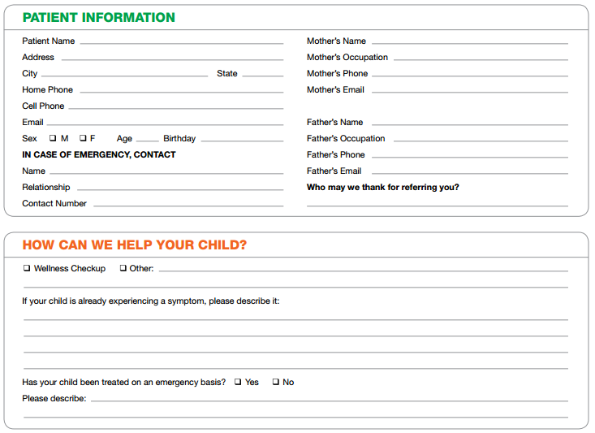
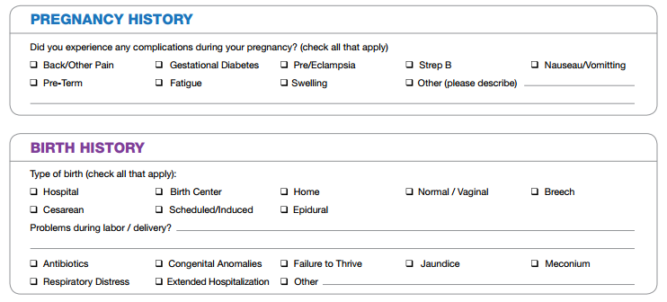

Patient/Guardian’s Signature _________________________________________ Date: ______________
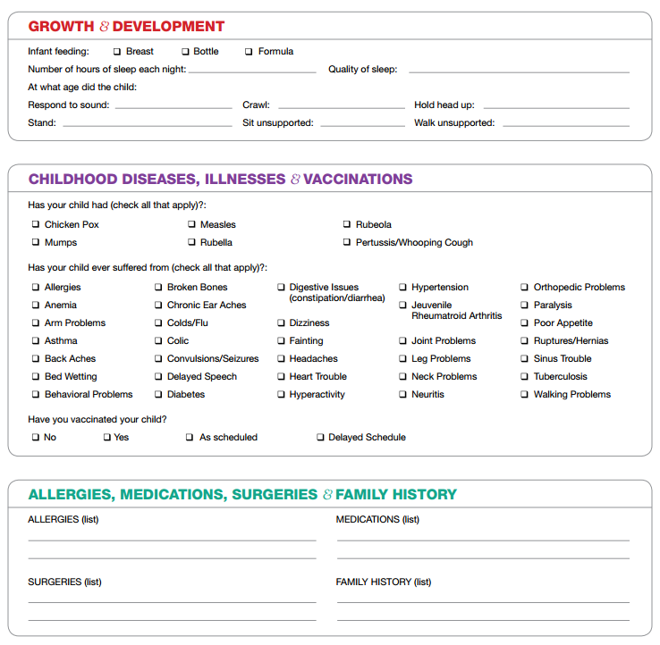
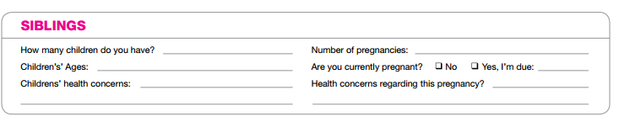
Authorization of Care of Minor
I hereby authorize Powell Family Chiropractic and Dr. Maceo Powell to administer care as they so deem necessary to my
son/daughter/ward.

Signed: _______________________________________________ Witnessed: _________________________ Date: _____________
234 N. Rhodes Ave.; Suite 105 ~ Sarasota, FL 34237
Phone 941.702.9944 ~ Fax 941.870.8948

