Healthy Living
Patient Information from the American Chiropractic Association
STAYING FIT AS YOU AGE
E
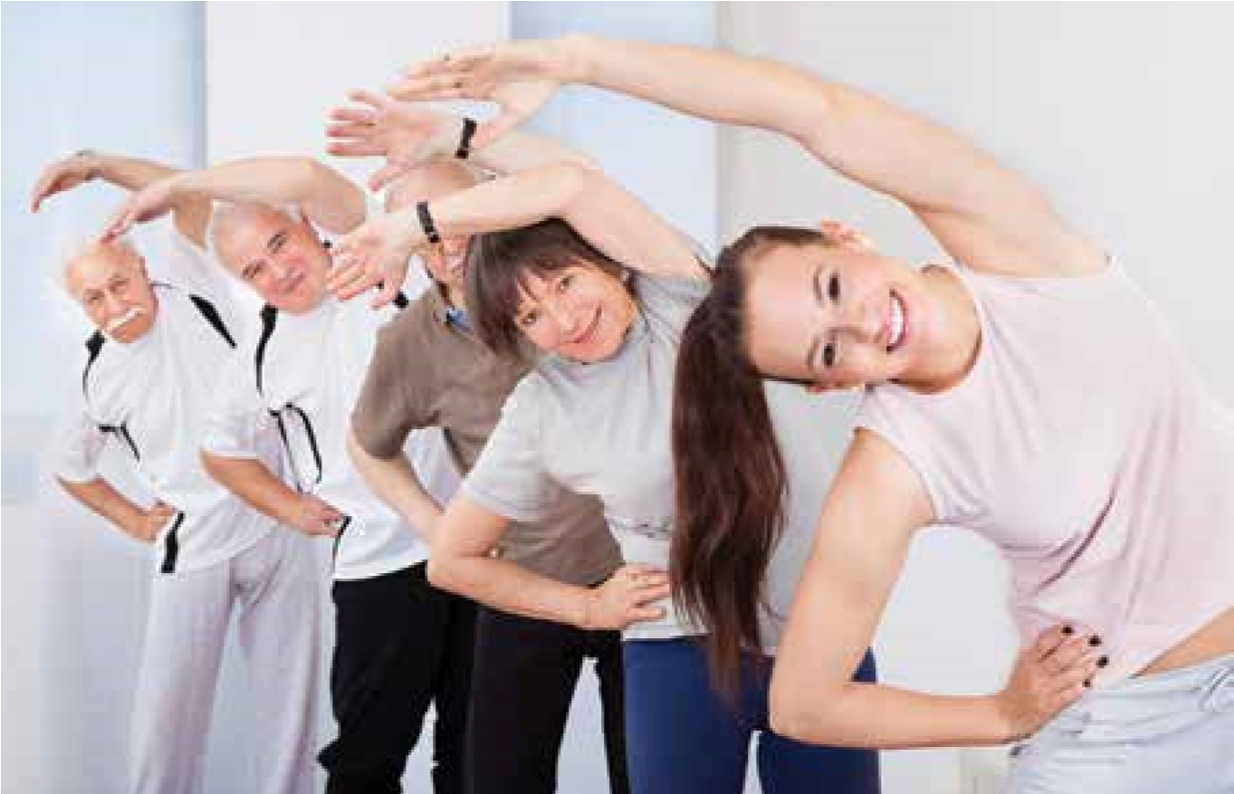
xercise is often prescribed for patients of all ages to reduce complaints about pain in muscles and bones. But some feel it gets harder to exercise as they get older.
“For seniors, exercise can also be an incredible way to be social,” says Dr. Scott Bautch, DC, a member of the American
Chiropractic Association’s Council on Occupational Health. “The social aspect of exercise is huge. Pilates is becoming more and more popular among older adults. Seniors can interact with each other while they exercise at their local gyms. Nowadays, many gyms have hours of operation that are friendly to seniors.”
the positive effects of fitness, you may increase the
Develop a plan for an exercise program and stick
with it. Make your exercise program an integral part
of your normal daily activities – or use normal daily
1701
Clarendon Blvd., Ste. 200 • Arlington, VA 22209 • 703.276.8800 • www.acatoday.org
Health and social benefits aside, many seniors still have questions about exercise:
Research has shown that exercise can reduce joint stiffness, pain and inflammation associated with arthritic conditions, which affect most of us as we age.
I’ve been inactive for so long. Won’t it hurt to exercise?
You can always become as physically fit as possible, given your current health status and limitations. When you commit to a
If you have been inactive for some time, you may feel physical fitness program, you will move toward enjoying some small aches and pains. They will fade with time. life more fully.
Be sure to tell your doctor if you experience any unusual
First, pick an activity that you enjoy doing and pain or other symptoms during or after your exercises. perform it regularly. Make your exercise program as
Check with your doctor of chiropractic before starting pleasant as possible. If you feel exercising is a chore, you any exercise or physical fitness program. While exercise will be uncomfortable with the program and will quit. is beneficial to your health, the type of exercises you
If you can, ask a friend to exercise with you so you can perform can be affected by your health status. support each other.
Second, begin your exercise program gradually, starting with five minutes of exercise each day. As you How do I start?
become more comfortable with the routine and notice exercise time.

activities to help your muscles and bones become as healthy as possible:
- Research shows that “functional exercises”— those that mimic actual daily activities, such as walking up and down stairs and getting in and out of a chair — can be quite effective.
- Some research suggests that people who live in two-story houses are less prone to certain types of heart disease. Repeatedly climbing a flight of stairs or rising from and returning to a seated position helps build leg strength and aerobic fitness. If you hold a weight during these exercises, you can increase your level of physical activity even further.
- Household chores, such as vacuuming, loading and emptying the dishwasher and moving wet laundry from the washer to the dryer can increase strength and flexibility. Lift with your legs, when necessary.
I don’t feel as strong as I used to. Can I still exercise?
As we age, we lose muscle mass. Some health care providers suggest that weight training will help prevent strength loss and keep patients feeling younger. Unfortunately, many seniors find they can’t lift the heavy weights necessary to actually build muscle mass. But don’t be discouraged. Recent studies show that while muscle strength diminishes with age, muscle endurance does not. It means that, as we get older, we may benefit from switching strength exercises to endurance exercises, working muscles with lighter weights but for a longer period of time.
Exercises that emphasize endurance, such as dancing, walking or bicycling, may be not only more beneficial but also more enjoyable. Many senior citizens have neighborhood areas where they can get together to walk. Walking with a family member or friend helps your physical fitness — and helps build relationships. These exercises are also aerobic and will benefit your heart health. For people who cannot walk or ride a bike, there are endurance- and flexibility-enhancing exercises that can be performed in a chair. Set goals for yourself that can be tracked, and make it a part of your overall health plan.
I have arthritis. How can I exercise safely?
Physical activity actually decreases arthritic pain. Many people with rheumatic conditions are physically inactive. There is oftentimes a fear factor for seniors when it comes to activity and arthritic pain – a social fear, a fear of pain, a fear of falling, etc. However, for those with arthritis, the worse thing they can do is stop moving. In most cases, you can — and should — exercise. In fact, recent research has shown that older people with arthritis gain modest improvements in physical function, pain, general mobility and flexibility, when participating in long-term exercise programs. Waterbased exercises, such as swimming or “water walking,” can work on joints without putting them through the stress of weight bearing. If necessary, your doctor can show you how to use a cane, a walker or other assistive devices to help prevent falls and injuries while you are physically active.
Healthy Living
Staying Fit as You Age
What fitness program will help me most?
The best exercise program should be tailored to your individual health status. Your doctor of chiropractic can help you plan the fitness program that is right for you. Typically, low-impact activities that keep joints moving and minimize pain, such as walking, swimming and water-based exercise, are effective. Research has shown that exercise can reduce joint stiffness, pain and inflammation associated with arthritic conditions, which affect most of us as we age.
Doctors of chiropractic can not only help restore muscle and joint function that have been affected by injury, illness and age-related conditions, but they can also maintain the health and flexibility of your muscles and bones. They often prescribe exercise to prevent and treat many of these conditions, helping older patients to remain active and independent.
For more information on prevention and wellness, or to find a doctor of chiropractic near you, visit ACA’s website at www.acatoday.org/patients or follow us @Acatoday.
This patient information page is a public service of the American Chiropractic Association. The information and recommendations appearing on this page are appropriate in most instances, but they are not a substitute for a diagnosis by a specialist. For specific information concerning your health condition, consult your doctor of chiropractic. This page may be reproduced noncommercially by doctors of chiropractic and other healthcare professionals to educate patients. Any other reproduction is subject to ACA approval.

1701 Clarendon Blvd., Ste. 200 • Arlington, VA 22209 • 703.276.8800 • www.acatoday.org

